**WEEK-2**

**PL/SQL PROGRAMMING SOLUTIONS**

**Exercise 1: Control Structures**

**CODE:**

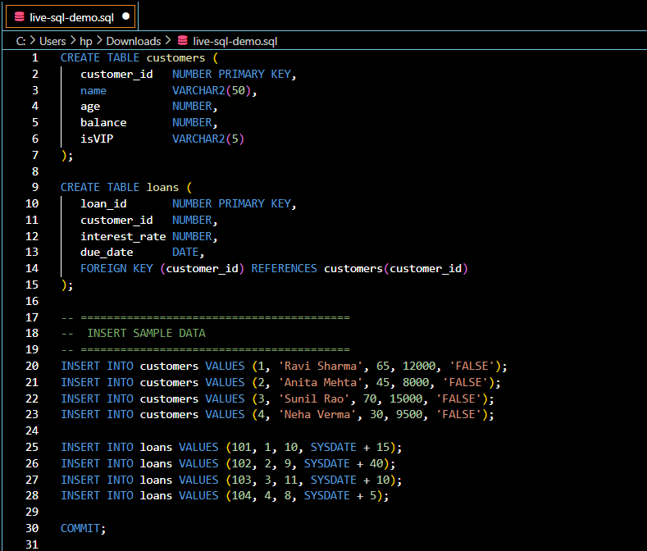

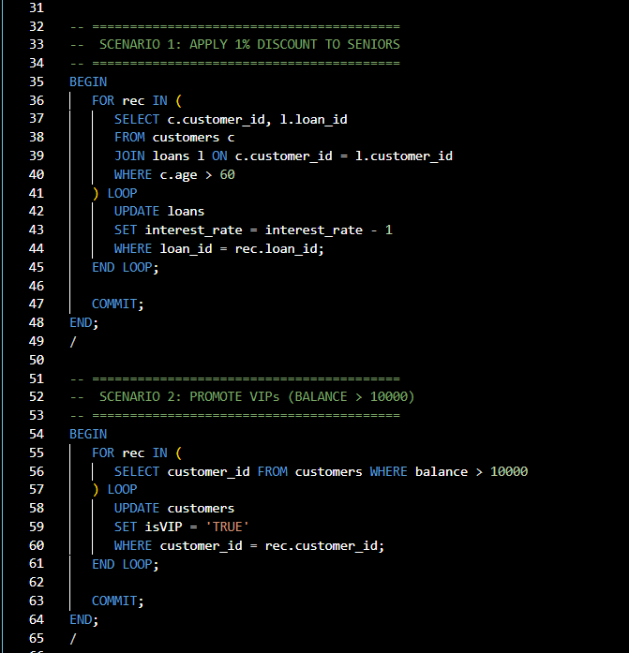

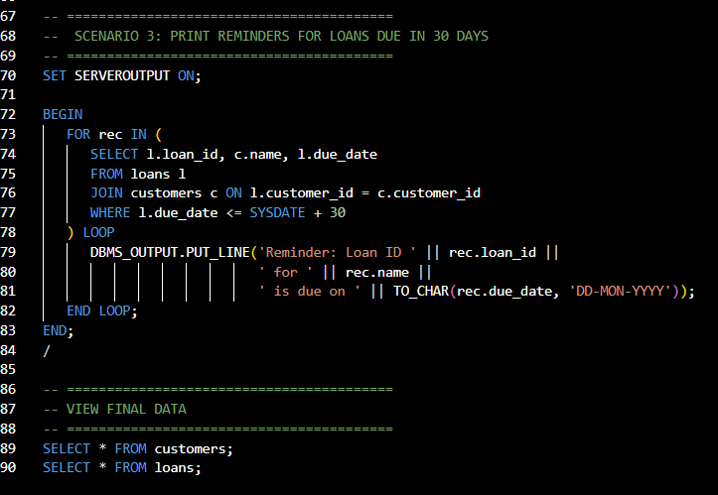

**OUTPUT:**

**SCENARIO 1-**

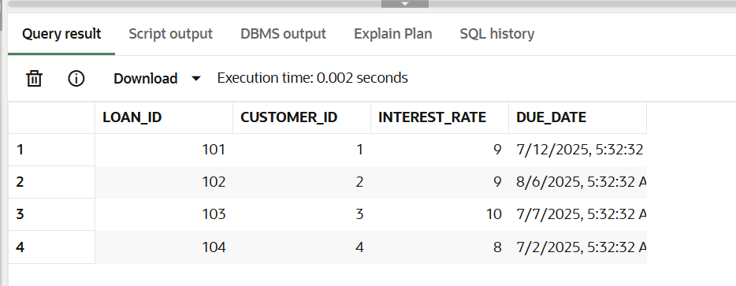

**SCENARIO 2:**

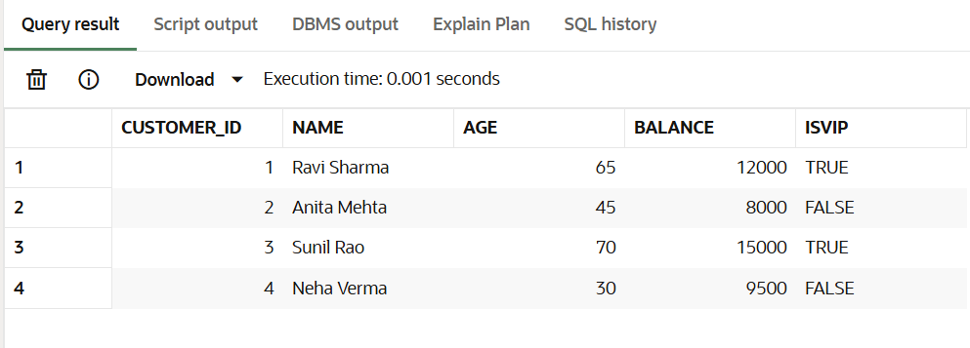

**SCENARIO 3:**

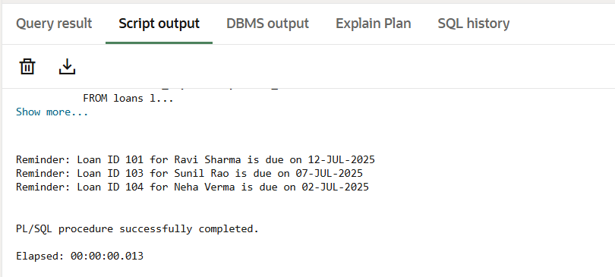

**Exercise 3: Stored Procedures**

**CODE:**

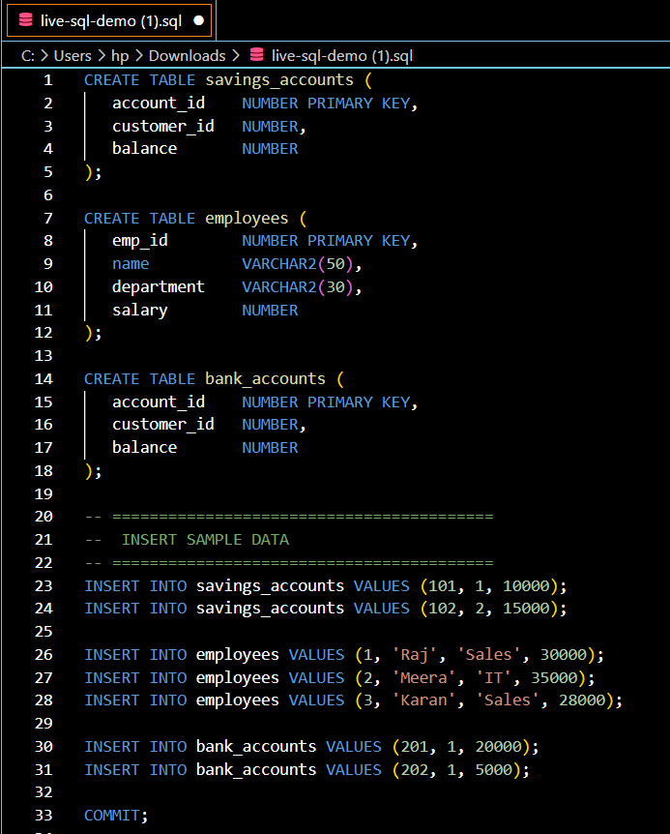

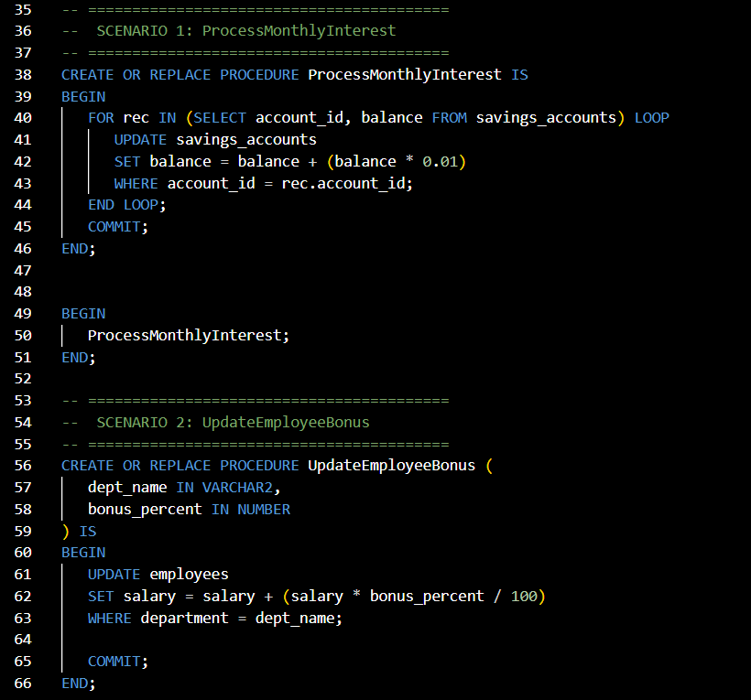

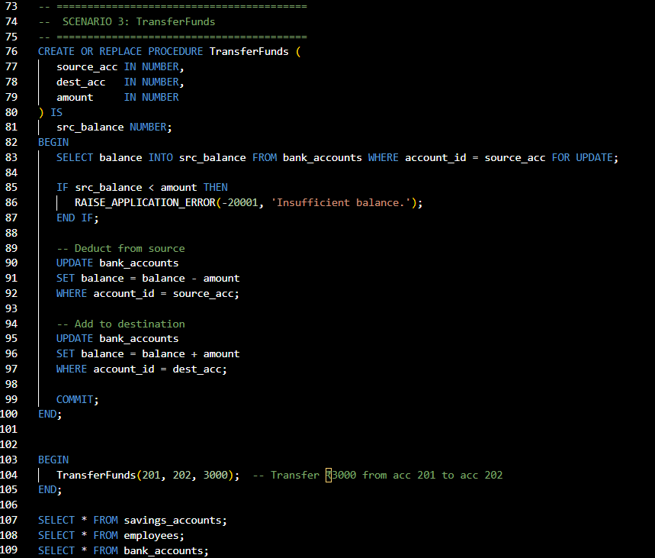

**OUTPUT:**

**SCENARIO 1:**

**Before Execution:**

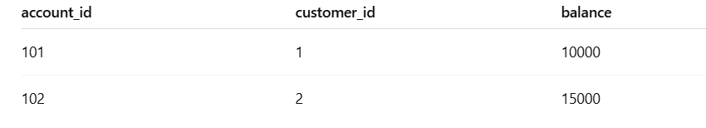

**After Execution**

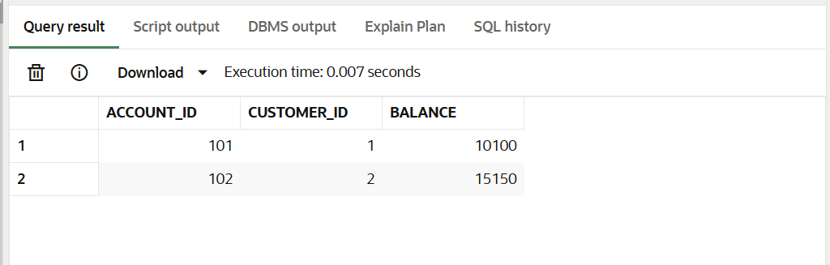

**SCENARIO 2:**

**Before Execution:**

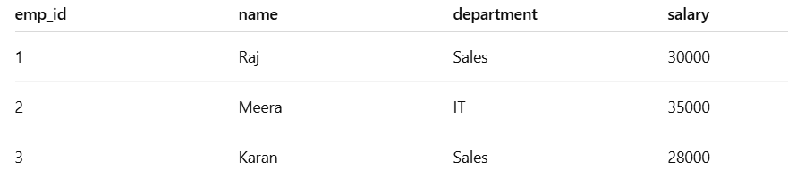

**After Execution:**

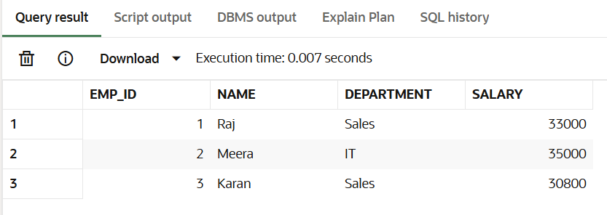

**SCENARIO 3:**

**Before Execution:**

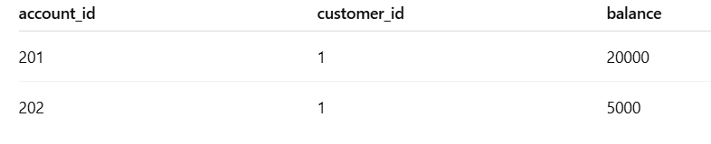

**After Execution:**

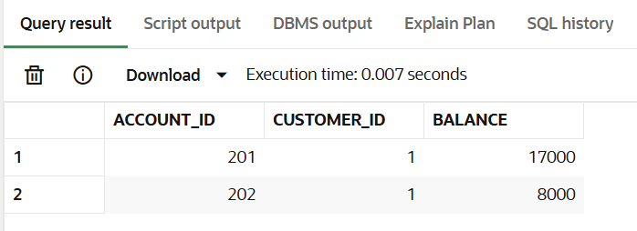

**Name- Manjeet Swaroop**

**SuperSetID: 6393474**

**EmailId:** [**manjeet.swaroop@gmail.com**](mailto:manjeet.swaroop@gmail.com)

**College: C.V RAMAN GLOBAL UNIVERSITY**